**Vishakhadatta**

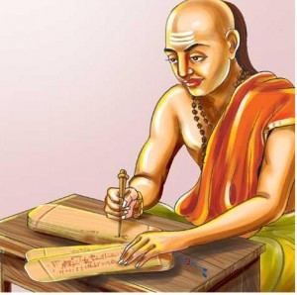

Vishakhadatta was one of the famous Sanskrit poet and play writer after Mahakavi Kalidas. Primer information of him is not widely propagated. He wrote magnum opus two plays, the Mudraraksasa and the Devichandraguptam. In these books, he wrote Sanskrit language with beautiful words. So that still we admire the themes of the books at present. His father and grandfather characters also narrated in these books as Maharaja Bhaskaradatta and Maharaja Vateshvaradatta.

**Mudrarakasasa**

The political play Mudrarakasasa amuse the readers for centuries. Here the Mudrarakshasa means the Rakshasa wearing the Ring. According to the characters of his father and grandfather indicated that he Vishakhadatta came from a princely family. Probably, their family had been involved in the political administration in the court of the kings or the local level.

Actually, he was not such a great scholar in Sanskrit language. Vishakhadatta had not proper literary education and grammar. He used the sentences in general form, but success to bound the readers and the spectators to the play with enthusiastic conversations between the characters. The poet was eminent to cultivate the conventions to focus on social life. Before him Kalidasa and Bhavabhuti were famous for their service to the Sanskrit literature. Both of them give high quality Sanskrit language and beautiful descriptions of the events in the plays. Kalidasa’s works were based on high culture and Bhavabhuti succeeded in philosophical erudition. But in prose of Vishakhadatta had certain stiffness in the conversations of characters.

#### **Devichandraguptam**

He another play named Devichandragupta, the story between Devi and Chandragupta. In the later years the story line had been reconstructed, but the concept of the theme was same. We can see the fragments of the Devichandragupta in King Bhoja’s two works named Natyadarpana of Ramachandra and Gunachandra. Few of the quotations of Vishakhadatta’s book explained widely by King Bhoja.

The story line in Devichandaguptam is very interesting. Once the Saka ruler cheated King Ramagupta and forced for humiliating treaty. Due to the treaty, Ramagupta send his Dhruvadevi to the Saka ruler. Then the main hero of the story Chandragupta, the younger brother of Ramagupta enter into the mater and kills Ramagupta and his own brother Ramagupta for the humiliation. Then he enthrone the Gupta Empire and married Ramagupta’s wife Dhruvadevi.  
In the modern period the English man Michael Coulson translated ‘Mudrarakshasa’ into English under the title of ‘Rakshasa’s Ring’.